Detection of Corona Virus Genome using Polymerase Chain Reaction with ELISA for detection for low copy number viral loads.

Date Created:
March 28, 2020

Author(s)
Eric W. Olle , Shannon D. McClintock and Rahul Gupta

Please read and understand all aspects of the protocol prior to starting. If you have any questions please contact the approving supervisor.

Approved by:

____________________________________ ________________
Laboratory supervisor Date

Page left intentionally blank.

- Scope and Application. This protocol was created as a way to detect the viral load in patients by modifying existing World Health Organization (WHO) interim real time Reverse Transcribed – Polymerase Chain Reaction (real time RT-PCR) to utilize alternative methods of detection.

- Summary. Real time RT-PCR is a standard technique that is derived from the standard PCR reaction originally developed in Cetus Corporation by Carry Mullis (sp?). This standard technique takes two oligonucleotides specific to the gene of interest and goes through repeated denaturing, binding oligonucleotide and extension using thermostable polymerase. Real time PCR uses the exponential growth and the Threshold value to determine the relative amount of nucleic acid present through the release of a fluorescent quencher by the incorporation /binding of a fluorescent oligonucleotide with a self-quenching structure. Initially, this was not done to determine the viral load but either the PCR was stopped mid-exponential growth and overall density was determined by gel-electrophoresis and an internal market. Since the overall goal of a diagnostic test is the presence or absence of a pathogen (in this case members of the corona virus family), it may not be necessary to use real time RT=PCR but a simple +/- test with experiment controls and not internal ratio controls such as human RNAse P. Therefore, an alternative method to amplify and detect the viral genome was made. Wherever possible the protocol will use the WHO primers, amplification protocols and controls. Where it will differ primarily is in the detection methods. For this protocol three different alternative will be shown and a couple other will be suggested base upon the equipment the laboratory has access. Nearly all labs have access to a PCR machine or if going old-school three different heat blocks and manual moving from different temps. Once amplified, the RT-PCR product can be quantified using spectrometer, gel electrophresis or ELISA The ELISA technique will use oligonucleotides conjugated to different haptens/antibody recognizing chemicals to capture the product. The presence and the amount of DNA can be measured through the incorporation of biotin-Cytosine. The product can them be quantified using OD or a simple – to +++ factored grading scale from the laboratory technician grading against know standards. Additionally, the PCR products can then be run on a gel to verify molecular mass of the product.

- Protocol Distribution and Usage by Personnel.

  - Distribution. These Standard Operating Procedures (SOP’s) will be made available to all staff and authorized subcontractors. SOPs are licensed under GPLv3 and Creative Commons-Share alike or equivalent. Feel free to modify but share with others.

  - Usage. Relevant SOPs must be followed for all procedures.

  - Qualification. ny laboratory personnel trained in or experienced in PCR, gel electrophoresis and ELISA techniques.

  - Version number. Version number 1.0. This SOP supersedes any previously used methods or techniques.

  - Disclaimers. To be in compliance with this procedure, one must be familiar with applicable laboratory processes and all associated SOPs before beginning. Confirm this with laboratory supervisor.

- Definitions and Abbreviations.

SOP: Standard Operating Procedure
N/A: Not applicable
QA/QC personnel: Quality Assurance/Quality Control personnel. This person may be the study director, QA/QC manager, or other person as chosen by the supervisor.
FACS: Fluorescent Activated Cell Sorter
SIP: Sample Introduction Probe
dH₂O: Filtered, deionized water
PCR: Polymerase Chain Reaction
RT: Reverse Transcription
ELISA: Enzyme linked Immunosorbant Assay

- Health and Safety Warnings. The use of laboratory equipment, supplies, chemicals, and biological products presents a safety and health risk to personnel.

Other applicable SOPs for lab processes detail health and safety risks, and must be read prior to performing this procedure.
Material Safety Data Sheets (MSDS) should be read and understood.
Equipment manufacturer warnings – read and follow manufacturer’s guidelines.
Human cells are used, universal precautions must be taken.
WARNING If using ethidium bromide for DNA detection in the gel it will require proper disposal due to being a potential terratogen and toxicity.

- Contraindication for protocol usage.

  - Interference. PCR is an extremely sensitive technique and improper technique may cause false negatives. RNA is extremely unstable and the reverse transcription reaction may not be successful and may interfere with the quantification or qualification of viral genome being present

  - Enhancement. PCR is an extremely sensitive and improper technique may cause well to well contamination. Aerosol resistant tips are highly recommended and proper technique MUST be used at all times.

- Equipment and Materials.

  - Laboratory equipment.

Vortexer
Micro pipettes
Pipette
Thin-wall PCR tubes or plate
ELISA plate
37 °C incubator
PCR machine or three heat blocks at the correct temperature
micro centrifuge

  - General laboratory supplies.
Phosphate buffered Saline (PBS)
Phosphate buffered saline with 0.05 Tween– 20
Tris-buffered saline
Blocking buffer is PBS w Tween -20 and 0.25% Bovine serum albumin
NOTE: 0.05% (w/v) Sodium Azide (NaN3) can be added to PBS. If sodium azide is not used make sure to filter sterilize solutions.
Laboratory grade water
Inviitrogen/Themo Superscript III one-step RT-PCR
10 mM biotin-16-AA-dNTP stock solution (TriLink BioTech or equivalent)
Forward and Reverse primers (see Appendix A for WHO primer sets)

  - Consumable products.
PCR consumables
micro centrifuge tubes
aerosol resistant tips
UV PCR enclosure hood
96 well plates
anti-DNP antibodies
strepavidin with appropriate conjugate enzyme

- Quality Control.

  - Calibration.
Make sure the micro pipettes are calibrated to deliver the appropriate volume
If using a plate reader make sure it operating correctly and use calibration plate if needed.

  - Quality Control.

    - Positive control. As a positive control, a known postive swab may be used or a standard in vitro transcribed template (see support protocols). Additionally a human RNAse P should be used as an individual sample positive control. The RNAse P can be run on the same plate or as a separate experiment to verify reqults.

    - Negative control. A standard water blank should be added to all plates including the RNAse P control. PCR is extremely sensitive to contamination and this is absolutely needed.

- Procedures.

  - Extract the RNA
    - Given a standard swab or serum follow the manufacturers instructions for RNA purification. Acceptable methods for RNA extraction include: Qiagen viral RNA mini kits (DSP, Qiamp and EZ1), Roche magnetic magNA pure (LC and Compact) along with others. See WHO and US CDC for additional guidelines
    - Keep RNA on ice, frozen and reduce manipulation to maintain nucleic acid integrity
    - Prepare all samples in a dedicated nucleic acid area to minimize contamination of PCR.
    - Perform all PCR preperation in a UV treated hood or PCR specific enclosure.
    - Use immediately after extraction or freeze at -20 ° C for later analysis.
  - Set up the the 96 well plate sample template
    - Using a standard 96 well plate template set up the goal for the PCR reaction. Include all samples in duplicate at a minimum and include both negative and positive controls in duplicate.
    - Verify the PCR machine is free and set to appropriate cycling parameters (Appendix A) for the current primer pairs.
    - Use this time to thaw the necessary reagents on ice.
  - Verify correct nucleotide and primmer mixtures.
    - This protocol differs from standard PCR and end user must verify that one primer is conjugated to DNP and the nucleotide mix contains biotin-16-dCTP at 50% dCTP nucleotide to allow for rapid detection. This is done by either making up your own one step RT-PCR kit with nucleotide mix OR adding extra 16-AA-Biotin-dCTP to the mix doubling the t
      - Alternatively for high concentration RNA transcripts, matching primer pairs can have one DNP and one biotin, conjugated.
      - Positive control: Use the USA RP primer pair mix as a positive control for Human RNAse P. Can be done on same plate or separate plate.
  - Set up the master mix
Determine total number of reactions plus extra (i.e. for 96 well plate plan on 100 reactions)

Master Mix | Per Reaction (in μL)
RNAse free water | 2.1
2 x Thermo Fischer Superscript II One Step RT-PCR system. | 12.5
MgSO₄ (50 mM) | 0.4
BSA (1 mg/ml) | 1
Forward Primer - DNP conjugated (10 μM stock) | 1
Reverse primer (10 μM stock) | 1
SuperScript III enxyme mix | 1
biotin-16-AA-dCTP (10 mM)  NOTE total dCTP ~ 0.8 mM | 1
Template RNA (bottom of well)  NOT PART OF MASTER MIX. | 5
Total reaction volume: | 25

    - Make up enough master mix minus template for the entire PCR plate.
    - Place 5 μL of of positive control, negative control and samples in the bottom of the well.
    - Using a multichannel pipette and without touching the samples place 20 μL of the master mix minus template in each well.
    - Gently mix and tap to the bottom of the thin walled tubes
    - Overlay with mineral oil of silicone oil if necessary (i.e. not a hot-top PCR machine)
    - Place the reaction into a prewarmed PCR machine and cycle as follows:
1 Cycle: 52 °C for 15 min and 94 °C for 2 min
35 Cycles: 94 °C 15 seconds, 55 °C for 30 sec and 68 °C for 1 minute
1 Cycle: 68 °C for 5 min
    - When completed, place on ice or free and prepare for analysis.

  - Analysis of PCR product using ELISA
    - Coat an immunolon plate with monoclonal DNP antibody overnight
      - Make up 6 ml of 0.1 μg/ml of monoclonal anti-DNP from Sigma Aldrich (D8506) or equivalent in PBS
      - Add 50 μl/well of diluted capture antibody.
      - Tap to the bottom cover with plastic wrap with moist paper towel and incubate overnight at 4 °C.
    - Tap out coating solution
    - Wash plates three time with PBS with tween 20
    - Tap out on paper towel to remove excess
    - Add 200 μL of 1% BSA in PBS-t and incubate at 25 °C for 1 hour
    - Wash three times with PBS-t
    - Tap out and 100 μL of 1% BSA in PBS-tμ
    - Using a multi-channel pipette add 5 μL of PCR reaction to each well and pipette up and down to mix.
    - Incubate for 2 hours at room temp with gentle mixing
    - Wash three time with PBS-t
    - Tap to remove
    - Add 100 uL of strepavidin-HRP diluted 1:10000 in PBS-t with 1%BSA (Double check dilution and make according to manufacturers recommendation)
    - Incubate 1 hour at 25 °C with gentle mixing
    - Wash 3 times with PBS-t
    - Gently tap on paper towel to remove excess liquid
    - Make 6 ml of colorometric reagent by diluting the BCIP/NBT Chromagen diluted 1:1.
    - Add 50 μl per well in to each well
    - Cover plate and incubate in the dark checking every 2 minutes looking for color change.
    - Add 50 μl stop reagent (2N sulfuric acid) when the +/- control starts to turn but not the negative control Or add stop just as the negative control wells starts to show background when placed on a white sheet of paper (estimated max time @ 15 min)
    - Once stop has been added take a picture on a white sheet of paper for documentation
  - Qualitative reading of the ELISA plate
    - If no plate reader is available look at the positive and negative controls and set a grading scale of: -, +/-, +, ++,, +++ to indicate strength of the reaction. A standard of pooled COVID-19 positive RNA extraction OR in vitro transcribed RNA generated from appropriate linear DNA (see support protocol) can be used and frozen in aliquats to aid in grading.
    - Using the pre-filled 96 well plate template record the grade
    - Correlate the viral score with the RNAse P control to verify sample integrity
  - (OPTIONAL) Quantitative reading of the ELISA Plate
NOTE: Please use manufacturers recommendation and internal SOP for reading the plate
    - Read the plate at 450 nm and a background correction of 540 or 570 nm. This is dependent on photometer used and if using a fixed wavelength plate reader use the appropriate wavelength

- Data Analysis and Calculation.
  - Basic
    - Given the grading scale report the patient reaction with a +/- being a possible positive result depending on background. Sample that pass the first screening test should be further verified.
    - Samples that have a negative human RNAse P are not usable due to lack of positive control and should be reported as not valid.
  - Quantitative
    - Read the plate at both 450nm and 570nm total OD_{adjusted} = OD₄₅₀ – OD₅₄₀
    - If an exact amount of viral RNA present, a standard curve using in vitro transcribe RNA or samples spiked with known number of viral particles can be used.
    - Calculate the estimated amount of protein based upon the curve fit to the standard curve.
    - Report as positive any sample that is fits to a level greater than a pre-set minimum dilution or any sample that has a minimum adjusted OD greater than the maximum negative control reading.
Note: This will should be regionally standardized and operate according to know statistical protocols. If you have any questions please contact a statistician.

- Waste Management.

All sharps must be disposed of following legally approved methods.
All pipettes are to be rinsed with 10% bleach, autoclaved, or both before disposal.
Liquid waste must be diluted so that final concentration of bleach is 10% and/or autoclaved.
Waste disposal must be in compliance with all applicable laws and regulations.

- References.

Current protocols in molecular biology
Rashtchian A and Mackey J (1987)
Lo, Y-MD, et al 1988 Rapid production of vector free porbes using PCR
Paul, N and Yee, J (2010) Biotechniques PCR incorporation of modified dNTP’s
WHO website and protocol manual
Add work flow
Add gel electro validation method (support protocol)

- Appendix.
  - Appendix A – WHO primer lists

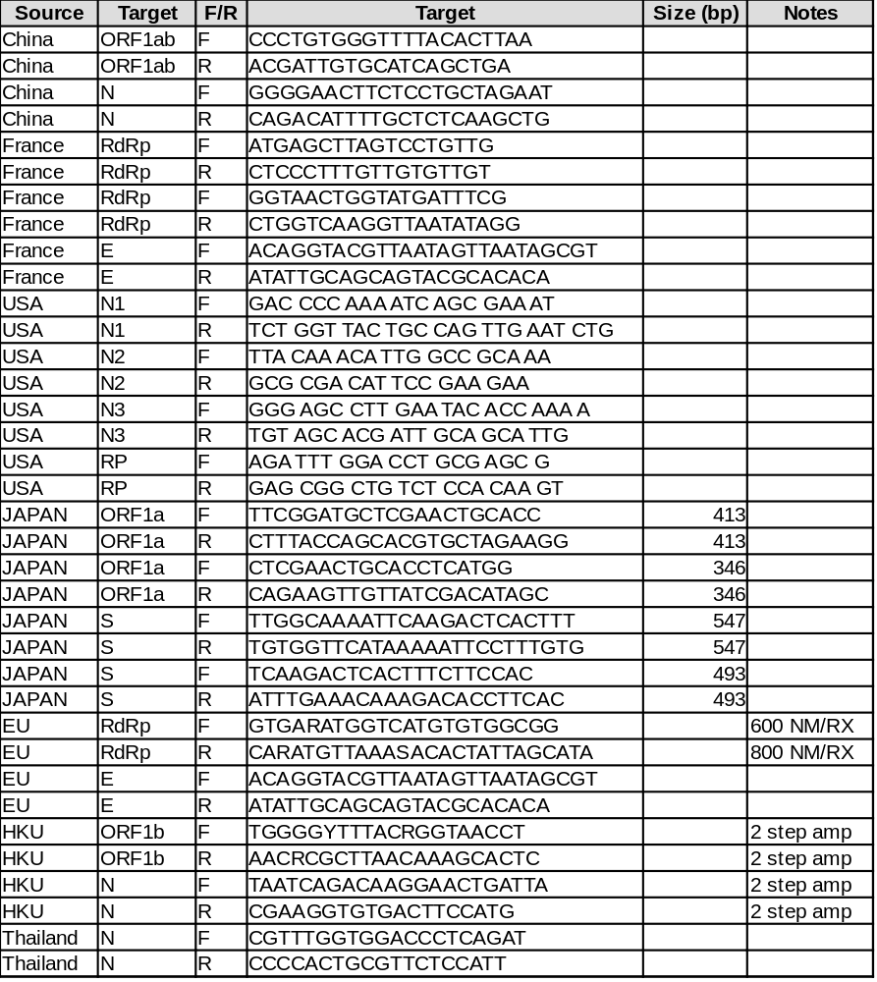

ADD Plate template
Add Paul reference
add a DIY single step RT-PCR recipe

- Revision History.

Reviewed
Initials
Date

Version 1.0 – Initial Release

